
Foundation University Islamabad
School of Science and Technology

Name: Hunaina Yasir Roll Number: 073
Subject: Programming Fundamentals Lab Section: B
LAB # 8
Tasks
8.1: Write a C++ program using function overloading. The name of the overloaded function is ‘square’. The different prototypes of this overloaded function are;
- void square(void);// Used to print a solid square of *s with side length of 5
- void square (char);// Used to print a solid square of the character passed as argument with side length of 6
- void square(char, int);// Used to print a solid square of the character and the side length passed as arguments to this function
Make calls to these functions one by one in your program.
SOURCE CODE:
#include <iostream>
using namespace std;

void square()
{
int i, j;
for (i = 1; i <= 5; i++)
{
for (j = 1; j <= 5; j++)
{
cout << "* ";
}
cout << endl;
}
}

void square(char ch)
{
int i, j;
for (i = 1; i <= 6; i++)
{
for (j = 1; j <= 6; j++)
{
cout << ch << " ";
}
cout << endl;
}
}

void square(char ch, int size)
{
int i, j;
for (i = 1; i <= size; i++)
{
for (j = 1; j <= size; j++)
{
cout << ch << " ";
}
cout << endl;
}
}

int main()
{
cout << "Hunaina Yasir" << endl;
cout << "Roll number: 073" << endl << endl;

square();
cout << endl;

square('#');
cout << endl;

square('@', 4);

return 0;
}

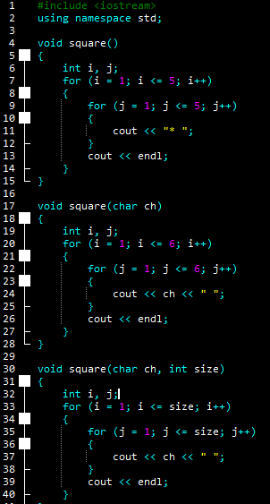
OUTPUT:
Hunaina Yasir
Roll number: 073

* * * * *
* * * * *
* * * * *
* * * * *
* * * * *

# # # # # #
# # # # # #
# # # # # #
# # # # # #
# # # # # #
# # # # # #

@ @ @ @
@ @ @ @
@ @ @ @
@ @ @ @

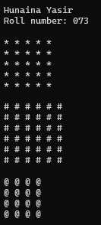
8.2: Write a function ‘swap’ in C++ language that swaps the values of two variables passed as arguments to this function. Write a C++ program which takes values of two integer variables from the user and swaps their values using function ‘swap’. Your program should have the following interface.
Enter the first value: 6
Enter the second value: 9
The two numbers have been swapped.
The first number is now 9.
The second number is now 6

SOURCE CODE:
#include <iostream>
using namespace std;

void swap(int &a, int &b)
{
int temp;
temp = a;
a = b;
b = temp;
}

int main()
{
int x, y;

cout << "Hunaina Yasir" << endl;
cout << "Roll number: 073" << endl << endl;

cout << "Enter the first value: ";
cin >> x;

cout << "Enter the second value: ";
cin >> y;

swap(x, y);

cout << "The two numbers have been swapped." << endl;
cout << "The first number is now " << x << "." << endl;
cout << "The second number is now " << y << "." << endl;

return 0;
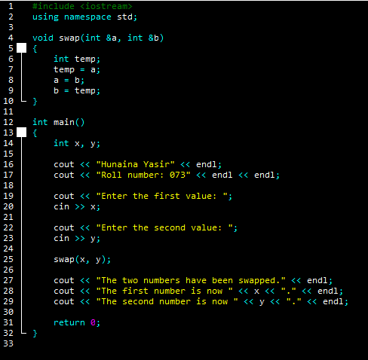
}

OUTPUT:
Hunaina Yasir
Roll number: 073

Enter the first value: 45
Enter the second value: 23
The two numbers have been swapped.
The first number is now 23.
The second number is now 45.
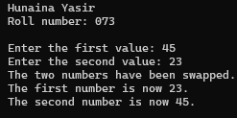
8.3: Explain the following code and show the output.
- #include<iostream>
- using namespace std;
- int main(){
- int factorial(int);
- int fact,value;
- cout<<"Enter any number: ";
- cin>>value;
- fact=factorial(value);
- cout<<"Factorial of a number is: "<<fact<<endl;
- return 0;
- }
- int factorial(int n)
- {
- if(n<0)
- return(-1); /*Wrong value*/
- if(n==0)
- return(1); /*Terminating condition*/
- else
- {
- return(n*factorial(n-1));
- }
- }

ANSWER:
This program calculates the factorial of a number using a recursive function. First, the program asks the user to enter a number and stores it in the variable value. The function factorial is declared before main so the compiler knows about it. When the user enters a number, the program calls the factorial function and passes that number to it. Inside the function, if the number is negative, it returns -1 to show an invalid value. If the number is 0, it returns 1, which is the stopping condition of recursion. Otherwise, the function multiplies the number by the factorial of the previous number and keeps calling itself until it reaches 0. Finally, the calculated factorial is returned to main and printed on the screen.
OUTPUT:
Enter any number: 3
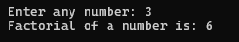
Factorial of a number is: 6

Exercises
8.1: Write a C++ program using function overloading to calculate absolute values of float and int in two functions. (Hint: absolute values of |5| = 5 and |-5|= 5)
Make calls to these functions one by one in your program.
SOURCE CODE:
#include <iostream>
using namespace std;

int absolute(int x)
{
if (x < 0)
return -x;
else
return x;
}

float absolute(float x)
{
if (x < 0)
return -x;
else
return x;
}

int main()
{
cout << "Hunaina Yasir" << endl;
cout << "Roll number: 073" << endl << endl;

int a = -5;
float b = -7.5;

cout << "Absolute value of integer is: " << absolute(a) << endl;
cout << "Absolute value of float is: " << absolute(b) << endl;

return 0;
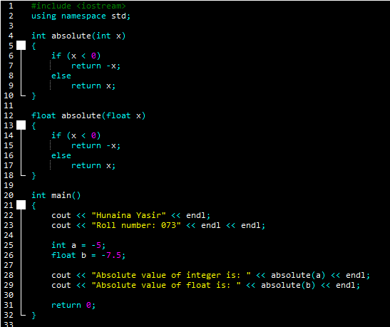
}

OUTPUT:
Hunaina Yasir
Roll number: 073

Absolute value of integer is: 5
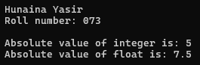
Absolute value of float is: 7.5

8.2: Define a recursive function named ‘generate numbers’ which takes single parameters named n and displays the series of numbers from 1 to N.

SOURCE CODE:
#include <iostream>
using namespace std;

void generateNumbers(int n)
{
if (n == 0)
return;

generateNumbers(n - 1);
cout << n << " ";
}

int main()
{
int n;

cout << "Hunaina Yasir" << endl;
cout << "Roll number: 073" << endl << endl;

cout << "Enter a number: ";
cin >> n;

generateNumbers(n);

return 0;
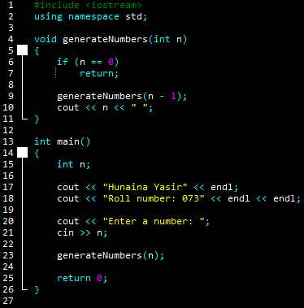
}

OUTPUT:
Hunaina Yasir
Roll number: 073

Enter a number: 2
1 2
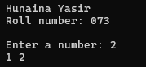

8.3: Define a recursive function named ‘power’ which takes two parameters, base and exponent, and returns the value equivalent to base multiplied by itself, exponent times.
SOURCE CODE:
#include <iostream>
using namespace std;

int power(int base, int exponent)
{
if (exponent == 0)
return 1;

return base * power(base, exponent - 1);
}

int main()
{
int base, exponent;

cout << "Hunaina Yasir" << endl;
cout << "Roll number: 073" << endl << endl;

cout << "Enter base: ";
cin >> base;

cout << "Enter exponent: ";
cin >> exponent;

cout << "Result: " << power(base, exponent) << endl;

return 0;
}

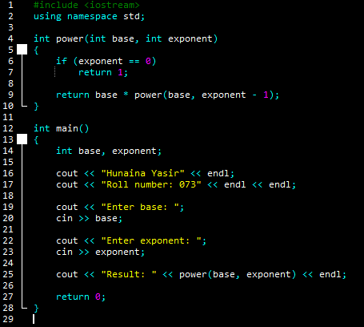

OUTPUT:
Hunaina Yasir
Roll number: 073

Enter base: 6
Enter exponent: 7
Result: 279936
